# **Caremark.com – View Prescription Rx History Website**

|  |
| --- |
| **Scenario/Member Statements** |

My medication is missing from my online prescription list.

Where can I find a list of my prescriptions?

I have medications at my local pharmacy, but I only see my mail order prescriptions, can you help?

My son is 9 and gets mail order prescriptions, where can I see them?

|  |
| --- |
| **Member Viewing Their Prescription List** |

Hover over the **Prescriptions** tab; click **View/Refill All Prescriptions** ORthe click the View/Refill All Prescriptions dashboard icon.

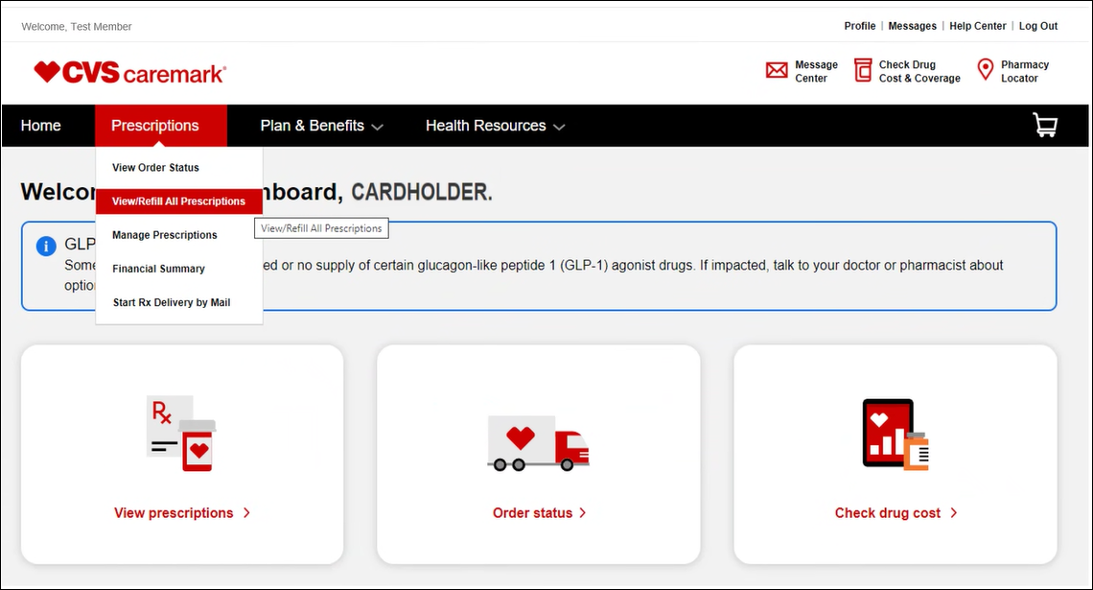

**Result: All Prescriptions** page displays:

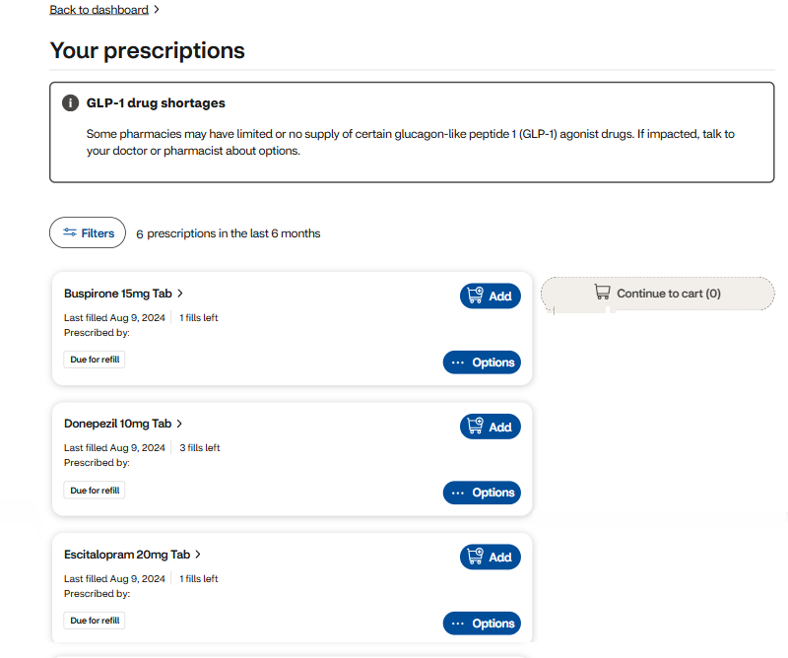

|  |
| --- |
| **Prescriptions Do Not Display Online** |

Member may not be able to view prescriptions under the View/Refill All Prescription page on their Caremark.com profile in the following circumstances:

* Member mailed in new prescriptions or physician sent in new prescriptions electronically.
  + If a new prescription is currently in process or recently shipped, the prescription may not be available from the refill list for up to 10 days after the date shipped.
  + After the new prescription is filled, the prescription will be available for the member to refill on Caremark.com going forward.

If a member has prescription claims in Compass, but the prescriptions are not listed on the View/Refill All Prescriptions page, after confirming they’re missing, submit a [Web Error Form](https://thesource.cvshealth.com/nuxeo/thesource/#!/view?docid=43ed6e8a-7e44-4cab-9831-eac9b6f67e7b).

|  |
| --- |
| **Related Documents** |

[Caremark.com - Common Member Assistance Call Types Index](https://thesource.cvshealth.com/nuxeo/thesource/#!/view?docid=947b0b38-401d-4b18-a08e-60348558a9b9)

**Full Details Document:**  [Caremark.com – View/Refill All Prescriptions - Integrated Pharmacy Experience (IPE)](https://thesource.cvshealth.com/nuxeo/thesource/#!/view?docid=ca9a6da8-e7b6-4eaf-aa3d-0c75eb4a6f06)

Not To Be Reproduced Or Disclosed to Others Without Prior Written Approval

**ELECTRONIC DATA = OFFICIAL VERSION / PAPER COPY = INFORMATIONAL ONLY**